Lab: Analysis of Skeletal Remains
You will be given the opportunity to identify skeletal remains on the basis of :
Gender – using the pelvis and skull
Race – using the maxilla and other characteristics of the skull
Age – based on general characteristics
Height – calculated based on the length of individual bones

Part I: Gender
For each pelvis that you observe, circle the appropriate answer in the chart below in order to determine gender:
(refer to figures below as needed for characteristics)
Characteristic | Pelvis A | Pelvis B | Pelvis C
Subpubic Angle (figure 2-1) | <90or >90 | <90or >90 | <90or >90
Pubis body width (figure 2-10) | 25-30mm / ~40mm | 25-30mm / ~40mm | 25-30mm / ~40mm
Sacrum Tilt | Forward / Backward | Forward / Backward | Forward / Backward
Pelvic outlet | Small / Large | Small / Large | Small / Large
Ilia | Close / Spread | Close / Spread | Close / Spread
Gender Determination | Male / Female | Male / Female | Male / Female

Figure 1 – Pelvis Characteristics for Males and Females: Figure 2: Pelvic measurements
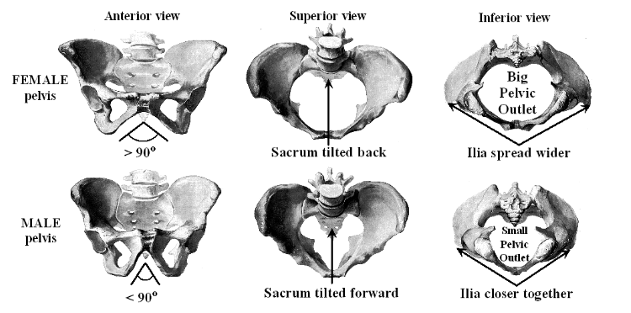
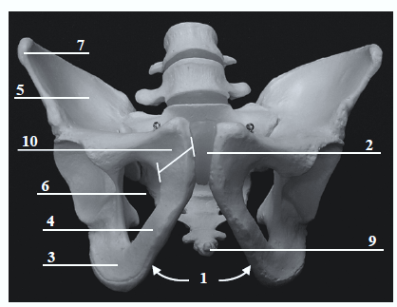

For each skull that you observe, circle the appropriate answer in the chart below in order to determine gender:
Characteristic | Skull A | Skull B | Skull C
Chin | Rounded / Square | Rounded / Square | Rounded / Square
Mastoid Process (behind ear) | Small / Large | Small / Large | Small / Large
Occipital Protuberance  (back of skull) | Small / Large | Small / Large | Small / Large
General Anatomy | Graceful / Robust | Graceful / Robust | Graceful / Robust
Forehead | Vertical / Receding | Vertical / Receding | Vertical / Receding
Brow Ridges (location of eyebrows) | Slight / Prominent | Slight / Prominent | Slight / Prominent
Muscle Lines | Slight / Prominent | Slight / Prominent | Slight / Prominent
Orbital Margins  (edge of eye sockets) | Sharp / Rounded | Sharp / Rounded | Sharp / Rounded
Angle of Ramus  (back corner of the jaw) | 90 / Obtuse | 90 / Obtuse | 90 / Obtuse
Gender Determination | Female / Male | Female / Male | Female / Male

Part II: Race
For each skull that you observe, circle the appropriate answer in the chart below in order to determine race:
(use the figures below as necessary to determine appropriate characteristics/measurements)
Characteristic | Skull A | Skull B | Skull C
Palate Arch Shape | Parabola / Rounded / Hyperbolic | Parabola / Rounded / Hyperbolic | Parabola / Rounded / Hyperbolic
Incisor shape | Spatulate / Shovel | Spatulate / Shovel | Spatulate / Shovel
Nasal width
Nasal height
NASAL INDEX | <0.48 / 0.48-0.53 / >0.53 | <0.48 / 0.48-0.53 / >0.53 | <0.48 / 0.48-0.53 / >0.53
Nasal spine | Prominent / Moderate / Small | Prominent / Moderate / Small | Prominent / Moderate / Small
Nasal silling/guttering | Sharp ridge (silling) / Rounded ridge/  No ridge (guttering) | Sharp ridge (silling) / Rounded ridge/  No ridge (guttering) | Sharp ridge (silling) / Rounded ridge/  No ridge (guttering)
Prognathism | Straight / Variable / Prognathic | Straight / Variable / Prognathic | Straight / Variable / Prognathic
Shape of Orbital openings | Rounded squares / Rounded circular / Rectangular squared | Rounded squares / Rounded circular / Rectangular squared | Rounded squares / Rounded circular / Rectangular squared
Race Determination | Caucasian / Asian / African | Caucasian / Asian / African | Caucasian / Asian / African

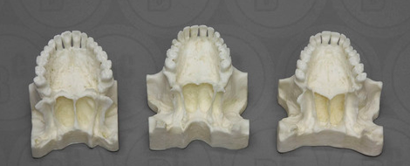
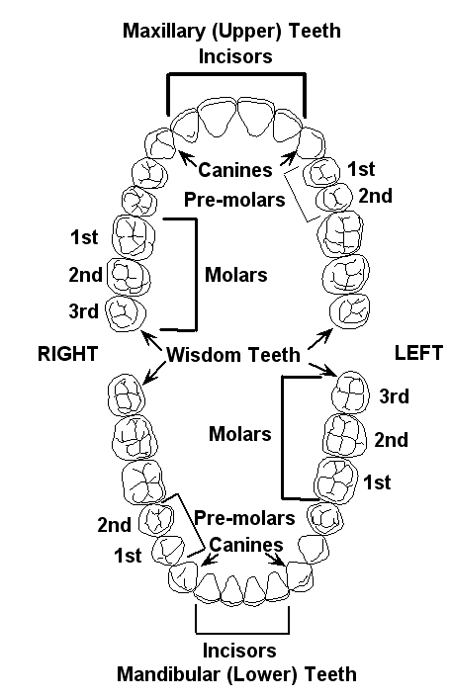
Figure 3: Adult Teeth Figure 4: Palate and Incisor shapes of different races
Spatulate shaped: Caucasian
Spatulate shaped: African
Shovel shaped: Asian
Parabolic Palate: Caucasian
Hyperbolic Palate: African
Rounded Palate: Asian

Part III: Long Bones
For each long bone (femur or humerus) that you observe, circle the appropriate answer in the chart below in order to determine gender or age: (use the figures below as necessary to determine appropriate characteristics/measurements)
Femur
Characteristic | Femur A | Femur B | Femur C
Vertical diameter of femoral head in mm  (figure 5-35) | N/A | <43.5 / 43.5-44.5 / 44.5 | <43.5 / 43.5-44.5 / 44.5
Bicondylar width in mm (figure 6, distance from 34-33) | N/A | <74 / 74-76 / >76 | <74 / 74-76 / >76
Maximum length of the femur in mm  (figure 6, distance from 28-34) | N/A | <405 / 405-430 / >430 | <405 / 405-430 / >430
Gender Determination | N/A | Female / Indeterminate / Male | Female / Indeterminate / Male
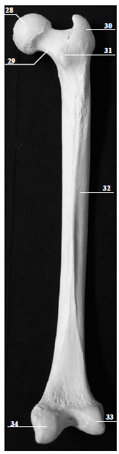
Figure 5: Femoral Head Diameter Figure 6: Femur Measurements
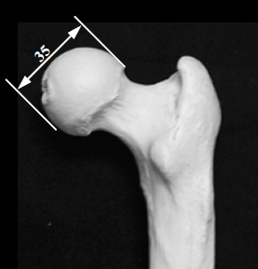

Humerus
Characteristic | Humerus A | Humerus B | Humerus C
Transverse diameter of humeral head in mm (figure 7a) | 37.0-39.0 / 42.7 – 44.7 | 37.0-39.0 / 42.7 – 44.7 | 37.0-39.0 / 42.7 – 44.7
Vertical diameter of humeral head in mm (figure 7b) | 42.7 / 48.8 | 42.7 / 48.8 | 42.7 / 48.8
Maximum length of humerus in mm (figure 8, distance from 36-40) | 305.9 / 339.0 | 305.9 / 339.0 | 305.9 / 339.0
Epicondylar width (figure 8, distance from 39-42) | 56.8 / 63.9 | 56.8 / 63.9 | 56.8 / 63.9
Gender Determination | Female / Male | Female / Male | Female / Male

Figure 7: Humeral Head Measurements
7a: Transverse diameter 7b: Vertical diameter
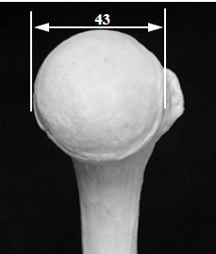
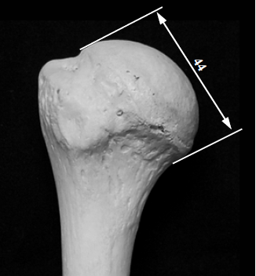

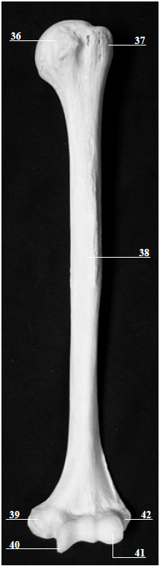

Figure 8: Humerus

Part IV: Age Determination
One way of determining age is by looking at the development of the cranial sutures. For each skull that you have access to, examine the sutures and fill out the chart below (use the included figures as needed)
Characteristic | Skull A | Skull B | Skull C
Frontal Suture | Present / Absent | Present /Absent | Present / Absent
Other Sutures | Open / Closed | Open / Closed | Open / Closed
Age Determination | Adolescent / Adult | Adolescent / Adult | Adolescent / Adult

Figure 9: Skeletal Suture Development
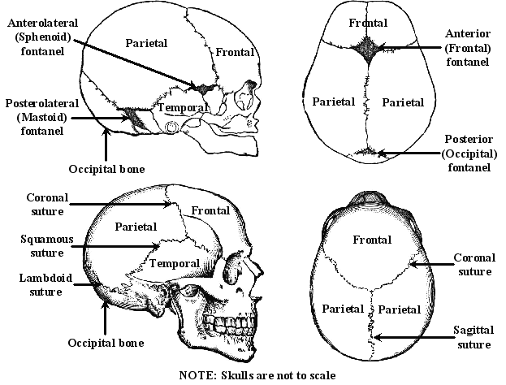

Pelvic Age Determination:
Circle the age of each pelvis according to the developmental occurrence characteristics observed on each pelvis. Use the pelvic figures referenced as needed.
Developmental Occurrence | Pelvis A (approx. age) | Pelvis B (approx. age) | Pelvis C (approx. age)
The pubis bone and ischium are almost completely united by bone (figure 2-10, 3) | 7-8 | 7-8 | 7-8
The ilium, ischium, and pubis bones are joined together (figure 2-5, 3, 10) | 13-14 | 13-14 | 13-14
The two lowest segments of the sacral vertebrae become joined together  (figure 10-8) | 18 | 18 | 18
The ilium, ischium, and pubis bones become fully ossified with no evidence of epiphyseal unions (indicated by cartilaginous lines) (figure 2-5, 3, 10) | 20-25 | 20-25 | 20-25
All segments of the sacrum are united with no evidence of epiphyseal unions (figure 10-8, 9) | 25-30 | 25-30 | 25-30
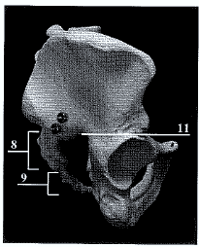
Figure 10: Pelvic Development

Femur Age Determination:
Circle the age of each pelvis according to the developmental occurrence characteristics observed on each femur. Use the femur figures from above as needed.
Developmental Occurrence | Femur A (approx. age) | Femur B (approx. age) | Femur C (approx. age)
The greater trochanter first appears (figure 6-30) | 4 | 4 | 4
The lesser trochanter first appears (figure 6-31) | 13-14 | 13-14 | 13-14
The head, greater trochanter, and lesser trochanter first join the shaft (figure 6-30, 31, 32) | 18 | 18 | 18
The condyles first join the shaft (figure 6-33, 34, 32) | 20 | 20 | 20

Humerus Age Determination:
Circle the age of each pelvis according to the developmental occurrence characteristics observed on each femur. Use the humerus figures from above as needed.
Developmental Occurrence | Humerus A  (approx. age) | Humerus B  (approx. age) | Humerus C  (approx. age)
The head and tuberosities join to become a single large epiphysis (figure 8-36, 37) | 6 | 6 | 6
The radial head, trochlea, and external condyle blend and unite with the shaft (figure 8-41, 40, 38) | 16-17 | 16-17 | 16-17
The internal condyle unites with the shaft (figure 8-39, 38) | 18 | 18 | 18
The upper epiphysis unites with shaft (figure 8) | 20 | 20 | 20

Part V: Height ~ using long bones
For each skeleton plug in the maximum length of the long bone asked for in the chart. You will have to use the gender and race you have determined from your analysis thus far. Use the stature formula figure below as needed.
 | Skeleton A
Gender | Race | Humerus Length | Calculations  (SHOW WORK) | Height  (in cm) | Height  (in in) | Height  (in ft + in)
 | Skeleton B
Gender | Race | Femur Length | Calculations  (SHOW WORK) | Height  (in cm) | Height  (in in) | Height  (in ft + in)
 | Skeleton C
Gender | Race | Femur Length | Calculations  (SHOW WORK) | Height  (in cm) | Height  (in in) | Height  (in ft + in)

Figure 11: Stature formulae
Race/gender | Bone | Formula = Height in cm
African/male | Humerus | 2.88 (max length in cm) + 75.48
Caucasian/male | Humerus | 2.89 (max length in cm) + 78.10
Asian/male or female | Humerus | 2.68 (max length in cm) +83.19
African/female | Humerus | 3.08 (max length in cm) + 64.67
Caucasian/female | Humerus | 3.36 (max length in cm) +57.97
African/male | Femur | 2.10 (max length in cm) + 72.22
Caucasian male | Femur | 2.32 (max length in cm) +65.53
Asian male/female | Femur | 2.15 (max length in cm) +72.57
African/female | Femur | 2.28 (max length in cm) + 59.76
Caucasian female | Femur | 2.47 (max length in cm) + 54.10

Final Step!!!! Composite for Each Skeleton: fill out the chart below for each skeleton based on your observations from this lab
Skeleton | Age | Race | Gender | Height (ft, in)
A
B
C

