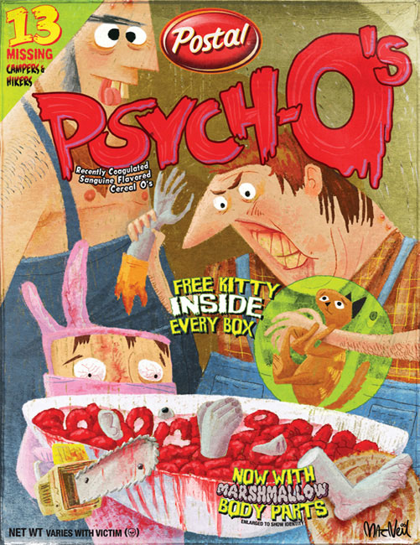
Serial Killer Research Project

In this project you will research one particular serial killer, and ONE OF THE FOLLOWING: criminal psychology OR forensic profiling. Your choice of psychology or profiling will depend on how you can relate the specialty area to your particular serial killer. While serial killers are fascinating and Hollywood has made them somewhat entertaining, ALL MATERIAL MUST BE SCHOOL APPROPRIATE!

Just as a cereal box has six sides, your project will have six “sides.” You will share your serial box with the class on Friday 12/15. These will remain on display in the room.

Front: Use the front to “showcase” your serial killer. You need to include graphics such as a picture of the person or something representative of the person, catchy slogans, and your cereal’s title displayed in an artsy way. You need to have a nifty manufacturer’s symbol.

Back: This side represents the “interactive” part of your project. Lots of cereals have crossword puzzles, mazes, riddles, hidden pictures, graphic organizers, etc. This section must convey content yet be entertaining. Factoids about the killer should be placed on this side. You should also place items on the back that CONNECT the serial killer with the forensic topic of psychology or profiling. Be creative!

Side One: Just as every cereal box has a list of nutritional facts and ingredients, use one of the sides of your box to generate a list of facts, dates, places, and names that are important to your project topic. This is where you will include a list of victims and their ages, when and where the attacks happened, evidence found, how they were killed (do not get graphic), anything else you feel you should include.

Side Two: This side is where you have a chance to elaborate on your chosen topic of Forensic Psychology or Forensic Profiling. Summarize this forensic specialty area by explaining the type of education/training a person would have to have, what these professionals do, and how this profession ties in with your serial killer. This should be a minimum of 3-4 paragraphs using an appropriate font size (make sure we can read it without a magnifying glass). Grammar and spelling are very important. Using the power to summarize versus a cut-and-paste approach is critical. It’s got to be in your own words as much as possible.

Bottom: This where you will put all of the sources you used. This includes where you found your pictures. If you used a website, I should be able to type the URL and go directly to the page you used and see that you did not just cut and paste.

Top: Please place your name, date, and topic on the INSIDE flap of the top but do not seal the top of the box since you will be placing several items within the box.

Inside the box: Find or make some trinket that would represent a prize that somehow symbolizes your topic. Provide a tiny description as to how the trinket applies (or place the description on the front or back of the box in a promotional way).

 | 4 | 3 | 2 | 1
Front | Creative name, Graphics, Slogan, Manufacturer | 1 element missing | 2 elements missing | 3 elements missing
Back | Interactive Element, Tie in of Forensic Topic to Killer, factoids | 1 element missing | 2 elements missing | 3 elements missing
Side One | List of facts &  Victims | 1 element missing | 2 elements missing | 3 elements missing
Side Two | Detail of Forensic Specialty, Education Requirements, Job description, tie in with killer | 1 element missing | 2 elements missing | 3 elements missing
Bottom | List of sources is complete | Have a list but no URLs | List is not complete | no sources
Top | Name, date, and topic written on the inside flap. | 1 element missing | 2 elements missing | 3 elements missing
Inside | Free inside prize is present and well thought out, description of tie in to your topic (this may be on the box) | prize is present but not completely logical with the topic, description of tie in | prize is present but no tie in information | no actual prize
Creativity | Exceptional | Swell | Okay | More effort please
Neatness/  use of color | Extremely neat and has an appropriate use of color | Neat but not colorful OR colorful but not neat | Neither neat or colorful | a mess!!!
Spelling/  Grammar | Perfect | Good | Okay | Spell/Grammar Check
Total: | /40 | = % | /75

