Mixed Gas Laws Worksheet
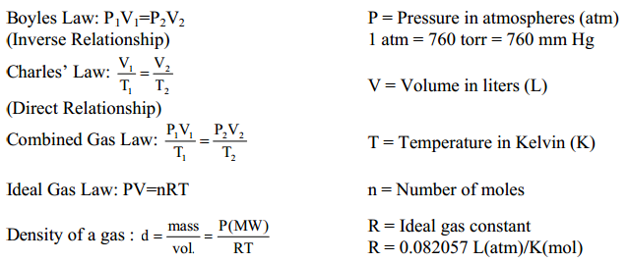
= 101.3 kPa

Dalton’s Law: P_{total} = P₁ + P₂ + P₃ +… (The total pressure of a mixture of gases = the sum of all of the partial pressures of each of the gases within the mixture)
Gay-Lussac’s Law: P₁ = P₂
T₁ T₂
(Direct Relationship)

Use the gas laws we have learned, above, to solve the following problems:
1) How many moles of gas occupy 98 L at a pressure of 2.8 atmospheres and a temperature of 292ºK? (Ideal)
2) A balloon is filled with 35.0 L of helium in the morning when the temperature is 20.0ºC. By noon the temperature has risen to 45.0ºC. What is the new volume of the balloon? (Charles’)
3) A 35 L tank of oxygen is at 315 K with an internal pressure of 190 atmospheres. How many moles of gas does the tank contain? (Ideal)
4) A balloon that can hold 85 L of air is inflated with 3.5 moles of gas at a pressure of 1.0 atmosphere. What is the temperature in ºC of the balloon? (Ideal)
5) CaCO₃ decomposes at 1200ºC to form CO₂ gas and CaO. If 25 L of CO₂ are collected at 1200ºC, what will the volume of this gas be after it cools to 25ºC? (Charles’)
6) A helium balloon with an internal pressure of 1.00 atm and a volume of 4.50 L at 20.0ºC is released. What volume will the balloon occupy at an altitude where the pressure is 0.600 atm and the temperature is –20.0ºC? (Combined)
7) A constant volume of oxygen is heated from 100°C to 185°C. The initial pressure is 4.1 atm. What is the final pressure? (Gay-Lussac’s)

8) A 75 L container holds 62 moles of gas at a temperature of 215ºC. What is the pressure in atmospheres inside the container? (Ideal)
9) 6.0 L of gas in a piston at a pressure of 1.0 atm are compressed until the volume is 3.5 L. What is the new pressure inside the piston? (Boyle’s)
10) A gas canister can tolerate internal pressures up to 210 atmospheres. If a 2.0 L canister holding 3.5 moles of gas is heated to 1350ºC, will the canister explode? (Ideal)
11) The initial volume of a gas at a pressure of 3.2 atm is 2.9 L. What will the volume be if the pressure is increased to 4.0 atm? (Boyle’s)
12) Air contains oxygen, nitrogen, carbon dioxide, and trace amounts of other gases. What is the partial pressure of oxygen (P_{O2}) at 101.3kPa of total pressure if it’s known that the partial pressures of nitrogen, carbon dioxide, and other gases are 79.1kPa, 0.040kPa, and 0.94kPa, respectively? (Dalton’s)
13) A sample of 25L of NH₃ gas at 10°C is heated at constant pressure until it fills a volume of 50L. What is the new temperature in °C? (Gay-Lussac’s)
14) Determine the total pressure of a gas mixture that contains oxygen, nitrogen and helium in the following partial pressures of 2.0atm for oxygen, 4.7atm for nitrogen and 253.25kPa for helium. (Dalton’s)
15) An ideal gas occupies 400ml at 270 mm Hg and 65°C. If the pressure is changed to 1.4 atm and the temperature is increased to 100°C, what is the new volume? (Combined)

Answers:

- 11 mol
- 38.0 L
- 260 mol
- 23 ⁰C
- 5.1⁰C
- 6.87L
- 5.0 atm
- 33 atm
- 1.7 atm
- 233 atm YES!
- 2.3 L
- 21.2 kPa
- 293⁰C
- 9.2 atm
- 112 mL

