Forensic Ballistics

What is forensic ballistics?

Forensic ballistics is the scientific analysis or interpretation of crime scene evidence relating to firearms (guns), cartridges (includes bullets, primer and gun powder) and cartridge cases. The most common types of crime scene evidence include: bullet holes/damage on various mediums, bullet trajectories, gunshot wounds and residues. Forensic Ballistic examinations are divided into three sub-categories: Internal, External and Terminal Ballistics.
----------------------------------------------------------------------------------------------------------------------------------------------
1) Internal Ballistics: What happens inside the weapon when a shot is fired. Includes the study of various firearm mechanisms, barrel manufacturing techniques, factors influencing internal gas pressure and firearm recoil.

- Examining the working mechanisms of firearms to determine the cause of accidental discharge.
- Examining home-made devices (zip-guns) in order to determine whether or not they are capable of discharging ammunition effectively.
- The microscopic examination and comparison of fired bullets and cartridge cases to determine whether or not a particular firearm was used.
---------------------------------------------------------------------------------------------------------------------------------------------
2) External Ballistics: What happens after the bullet leaves the weapon until it strikes the target.

- The calculation and reconstruction of bullet trajectories.
- Establishing the maximum range of a given bullet.
--------------------------------------------------------------------------------------------------------------------------------------------
3) Terminal Ballistics: What happens (to the target or to the projectile) when it hits the target. Target can be a solid or liquid object, but when the target is a human or animal it is common to use the term “wound ballistics”.

- The determination of the distance between firing point and target.
- Establishing whether or not a particular wound was caused by a fired bullet.
- Determining the caliber and type of projectile that caused bullet damage or gunshot wound.
- Identifying the bullet exit/entrance by examining the holes in the targets, or the wounds in biological tissue.
- The examination of ricochet possibilities on targets and fired projectiles.
----------------------------------------------------------------------------------------------------------------------------------------------

Types of Firearms

In most criminal investigations involving the use of firearms, Forensic scientists typically examine three types of firearms: HAND GUNS, RIFLES and SHOTGUNS. Each type of firearm is unique in terms of its structure and function, the types of ammunition that can be used with it, and its ballistic properties defined by velocity, kinetic energy and trajectory.

Distance: How far the bullet is projected from firearm. Velocity: Speed the bullet leaves the firearm.
Energy: Kinetic energy, mass multiplied by velocity. Trajectory: Path of bullet, determined by velocity & kinetic energy.

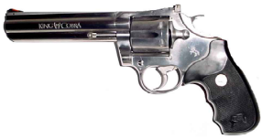
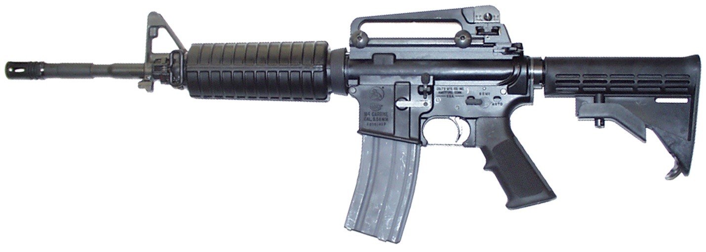

Rifle

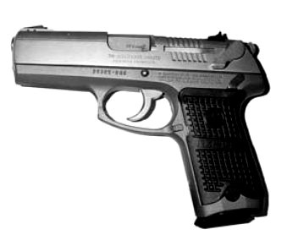
Handguns
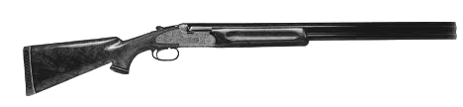

Shotgun

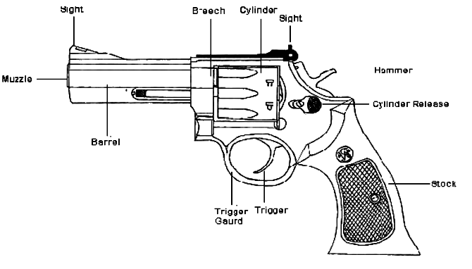
Hand Guns

- Revolver

The term “revolver” is derived from the fact that individual cartridges/rounds are loaded into a cylinder that revolves with each pull of the trigger. With each turn of the cylinder a cartridge is brought into line with the opening of the barrel. As the firing pin strikes the primer (located at the base of the bullet), the gunpowder in the shell casing explodes, forcing the actual bullet out of the cylinder, into the opening of the barrel, down the length of the barrel, and out the muzzle.
Revolvers typically hold six cartridges in a large variety of caliber’s, such as .22, .38, .357, and .44. Revolvers are not used in the law enforcement community because of low ammunition capacity and reloading time. The ballistic properties of revolver ammunition vary by caliber. Typically, handgun ammunition of the caliber’s mentioned above display low muzzle velocities and limited amounts of kinetic energy, except in larger caliber’s such as .357 or .44 Magnum. These guns rarely jam and are relatively inexpensive to manufacture.

- Pistol

Pistols are characterized by semi-automatic capabilities in which a slide sits atop the frame. Cartridges are loaded into a magazine which is inserted into the handle of the pistol. Pistols operate differently from revolvers in that the barrel sits inside the slide. Each pull of the trigger causes a new bullet to be drawn into the opening of the barrel as the slide moves backwards with the force of the recoil. The slide then returns to its forward position, locking the bullet into the barrel. When the trigger is pulled again, the process repeats itself. Pistol bullet velocities are considerably higher than a revolver’s.
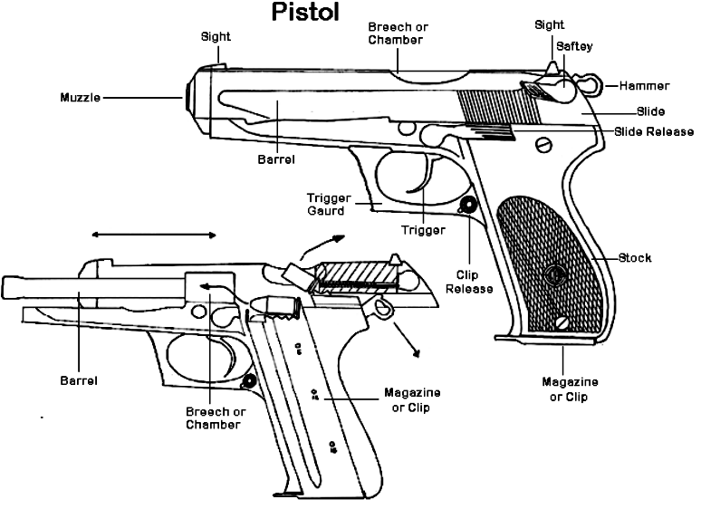
The unique design of semi-automatic pistols allows for 10-16 bullets per magazine, faster reloading times, and the ability to fire rounds in rapid succession. Pistol ammunition varies in caliber, with 9mm, .40 and .45 being the most common. Law enforcement agencies across North America have switched to pistols using either 9mm or .40 caliber ammunition. The ballistic properties of pistol ammunition vary widely, just as they do for revolver ammunition. Generally speaking, 9mm and .40 caliber rounds will possess roughly the same kinetic energy and muzzle velocity as .38 of .357 rounds fired from a revolver. While occasionally prone to jamming if not properly maintained, pistols provide an effective defense against most threats faced on the street by police officers.
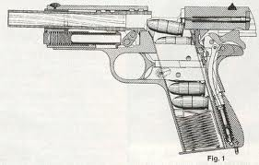

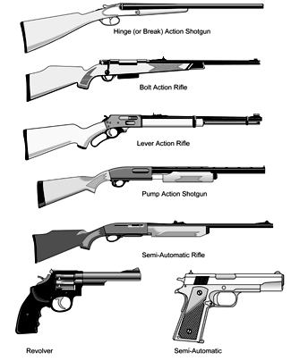
Rifles

- Bolt-Action Rifle

Bolt-action rifles are characterized by a bolt that sticks out the side, which allows the user to open the breech, extract a spent round, and chamber a new one into the barrel. They typically hold about 5 cartridges, are slow to reload and vary widely in caliber. The use of a telescopic sight, mounted along the barrel above the “action” of the rifle, increases the effective range of a bolt-action rifle to between 200 and 1000m, depending on its caliber. They are reliable and easy to maintain, used largely for sport and hunting.
Because of the large shell casing for their cartridges, such as .30-06 and 7mm caliber, their bullets can possess extremely high muzzle velocities and kinetic energy levels. A rifle bullet is larger, travels at a much faster speed and has much more energy than a bullet fired by handguns. Muzzle velocity, kinetic energy, and trajectory can vary widely, depending on the caliber of the rifle bullet. The trajectory of rifle bullets can in some cases be much flatter than what would be exhibited by handgun ammunition. For example, a handgun round might fall into the dirt after it has traveled about 200m. A rifle bullet might travel over 3km before burrowing into the earth!

B) Lever-Action Rifle

Once a round has been fired from a lever action rifle, the user cocks the gun by pushing the lever forward, then snapping it shut again. A typical lever action rifle can hold 5-6 rounds in its magazine. Lever action rifles typically utilize ammunition of the .30-30 caliber. This cartridge fires a heavy, relatively slow moving bullet which drops considerably over short distances. The low muzzle velocity and heavy bullet makes lever-action rifles a poor choice for long distance shooting, but suitable for hunting game in heavy brush. Versatile and durable, but low muzzle velocity and inaccurate over long distances.

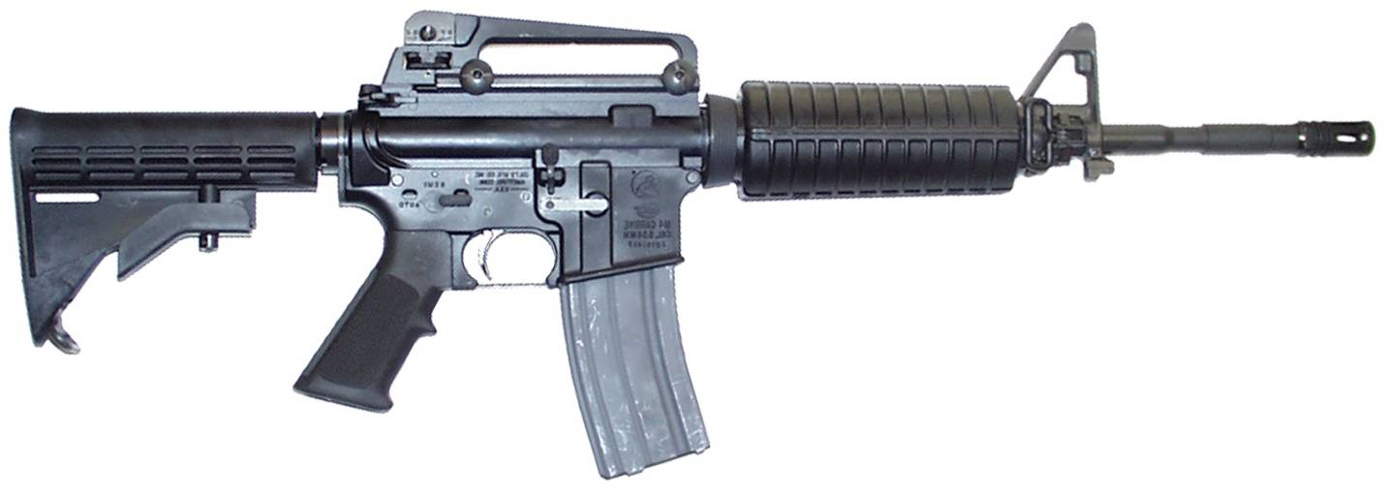
- Automatic Rifle

Typically referred to as “assault rifles”, automatic rifles are characterized by their ability to fire a continuous stream of bullets with each pull of the trigger. The AR-15 is the standard issue weapon used within the US military and increasingly within police agencies across North America. Automatic weapons are usually configured to operate in one of three different modes – single shot, semi-auto or full auto. Assault rifles are accurate to approximately 200m, but are designed to direct a large number of bullets at a target in a brief period of time. However, weapons such as the AR-15 can be modified for law enforcement use and are valued for their accuracy and stopping power.
Automatic weapons, whether machine guns, assault rifles, or submachine guns fire a variety of ammunition. Some of these rounds have flat trajectories, meaning the individual bullets travel great distances without falling to the ground. For example, a .223 round, commonly used in the AR-15, might drop only 1-2cm over the length of 2 football fields, 200m, making it highly accurate.

----------------------------------------------------------------------------------------------------------------------------------------------

Shotguns

Shotguns were designed to spray lead pellets over a large area, making them ideal for hunting birds or small animals that move quickly. The .12 gauge Remington 870 shotgun has been standard police issue for many years. Shotguns are every popular for hunting and sports due to their diversity and durability. Shotguns have a magazine capacity of 3-4 rounds.
Shotguns can fire a wide variety of shells, including birdshot, buckshot and rifled slugs. Birdshot typically consists of large numbers of small lead pellets packed within the shell, which sits atop a shell casing. Buckshot consists of a smaller number of lead pellets which are larger in diameter. A typical buckshot round used by police agencies would contain approximately 9 lead pellets, each the size of a small pea. Its effective range is limited to 20-30m. Rifled slugs are also used in shotguns, increasing the effective range to a 100m in length. Slugs are lead bullets about the size of a man’s thumb, and generate substantial amounts of kinetic energy over short distances. However, they rapidly lose height after approximately 100m, making shotgun slugs inaccurate past that distance.
Firearms & Ammunition Pre-Lab Questions

What is ammunition?
Can be called a cartridge or a round.

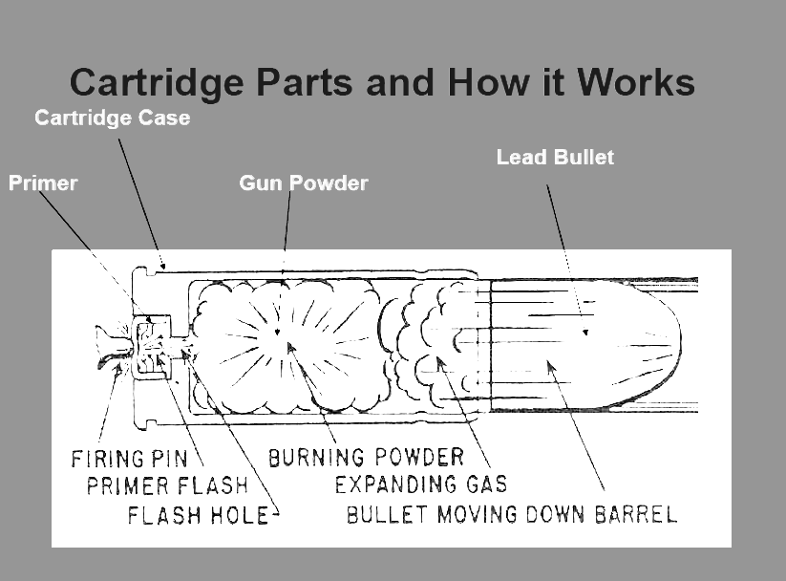
What is a cartridge and how does it work?
Each cartridge contains:
a casing / shell
a bullet / slug / shot
primer powder
gun powder

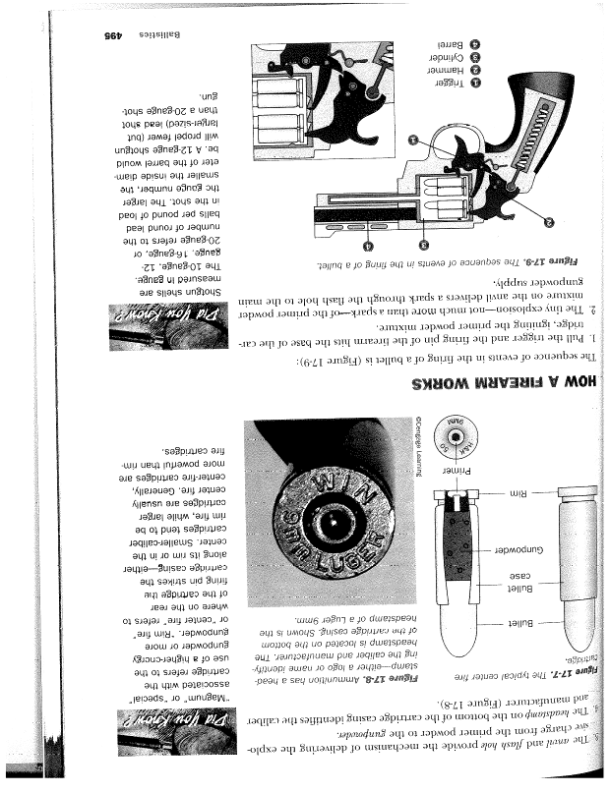
How does a firearm work?
When the trigger is pulled, the firing pin hits the base of the cartridge, igniting the primer powder mixture.
The ignited primer powder mixture delivers a spark through the flash hole to the gunpowder causing it to explode.
This forces the bullet/shot/slug down the barrel of the firearm. The spent cartridge casing will then be ejected.

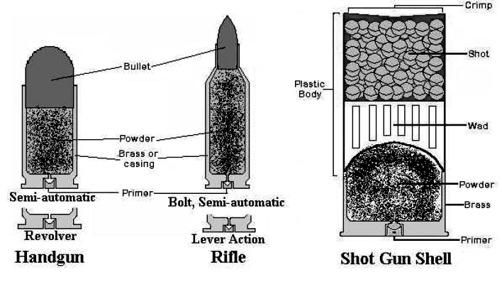
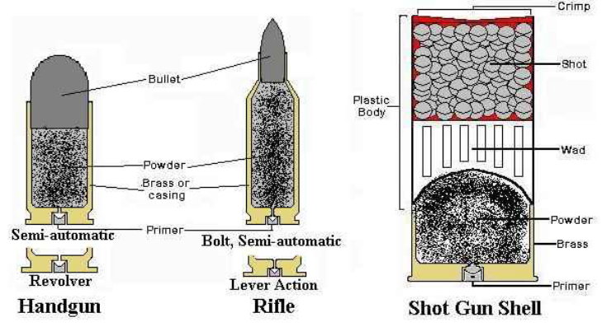
How do the characteristics of cartridges differ between the 3 different types of firearms?

1. Make an outline for the different types of firearms
I. _____________________________
a. _________________________

1. Create an outline for the types of firearms.
I ______________________________
a. _________________________
b. _________________________
II. _____________________________
a. _________________________
b. _________________________
c. _________________________
III. _____________________________

2. What is another name for a cartridge? ___________

3. What 4 things does a cartridge contain?
a. _________________________
b. _________________________
c. _________________________
d. _________________________

4. When the trigger is pulled, the firing pin of the firearm hits the base of the _______________________. This causes the __________________________ to spark, which causes the ______________________ to explode. This explosion forces the _________________ down the barrel of the firearm. The spent ________________________________________ will then be ejected.

5. Match the ammunition with its corresponding firearm.
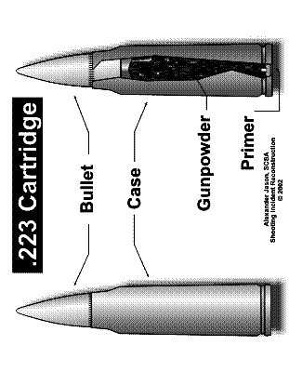
Handgun
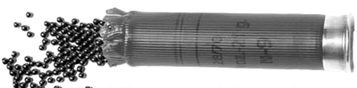
Rifle
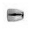
Shot gun

Lab Part 1: Bullet Survey – Caliber, Composition, Morphology & Manufacturer
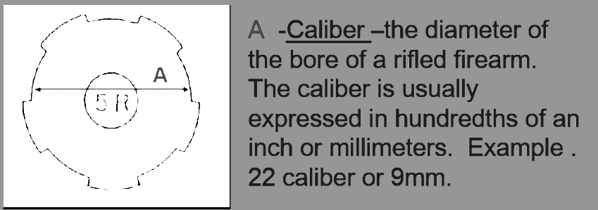
Bullets are named by caliber (width) and length. Caliber can refer to the measure of the diameter of the bore(barrel) or a gun, or to the diameter of a bullet that would be used with that gun. The caliber of ammunition should match the firearm that shoots it. In the US, bullets are usually measured in hundredths of an inch. (.22, .25, .357, .38, .44, .45). In Europe, metric is used. (9mm).
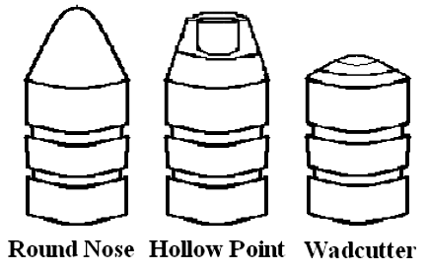
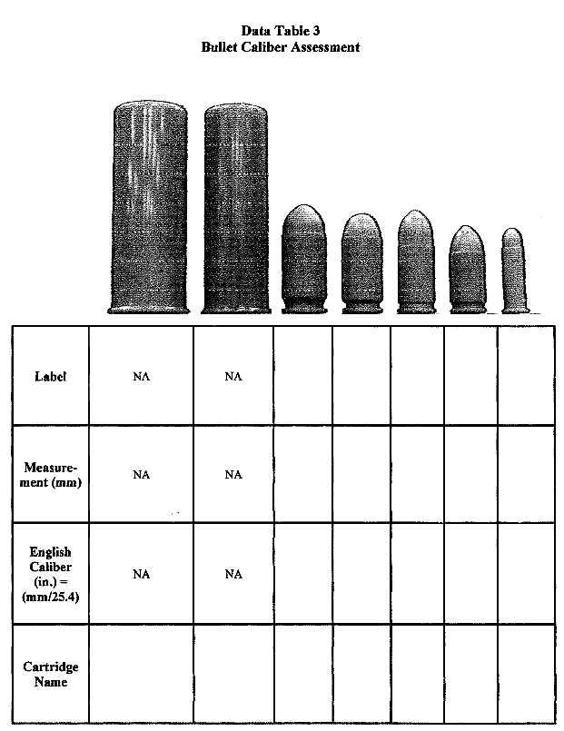
Bullets come in different sizes, lengths and shapes (round nose, hollow point, wadcutter). They can be made of different types of metals or other materials.

Procedure:

1. Pick up an orange, simulated round.

2. Use the Vernier caliper to measure the diameter of the widest portion of the bullet head in millimeters. This will be the place where the bullet head meets the casing. Record this value in the data table.
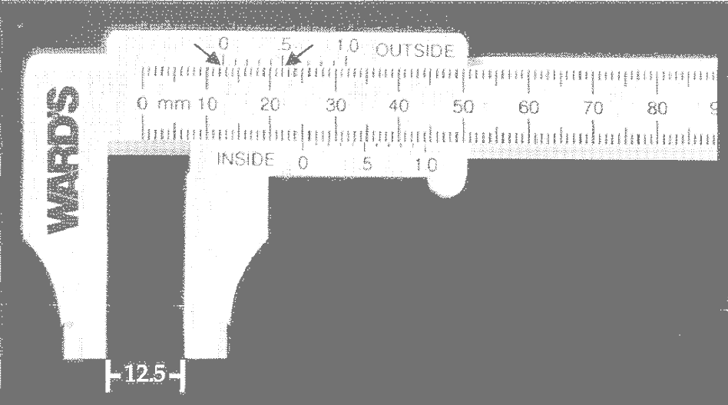

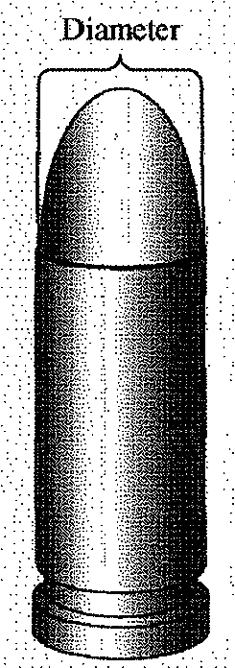

Using the Vernier Calipers: Use the movable portion of the caliper to lightly squeeze the bullet and then read the outside scale only [ ] located at the top of the caliper. The whole number is read at the “0” on the top of the outside scale and the decimal reading is made at the point at which the outside scale lines up exactly with a millimeter mark underneath it. Example above: The “0” mark lines up close to the 12 directly underneath it, so the bullet would be at least 12mm. The only number on the top 0 – 1.0 that directly lines up with a millimeter mark below is .5. So the width of this bullet would be 12.5mm.

3. Use a calculator to convert the millimeter measurement into inches by dividing millimeters by 25.4. (1inch = 2.54cm) Record your answer in the data table.

4. Repeat steps 1-3 for each of the remaining orange, simulated rounds. Shot gun cartridges do not need do be measured. Why?

5. Refer to the beginning of this packet that presents the different types of firearms and the types and calibers of ammunition they fire. Some rounds may be used in more than one type of firearm and some firearms may accept more than one caliber bullet if they are similar in size. See if you can guess the name of each cartridge in the data table above from the measurements you took. (Hint: Each is named for either the English or the metric measurement.)

FYI: There may be a second number that indicates the length of the cartridge (longer cartridge → more gun powder → bullet goes further) as well as letters that indicate a brand or the company that introduced them.

Lab Part 2: Bullet Analysis
Class Evidence – Rifling in barrel - Number, width and depth of lands and grooves, pitch and twist
Individualizing Evidence - Unique grooves & striations
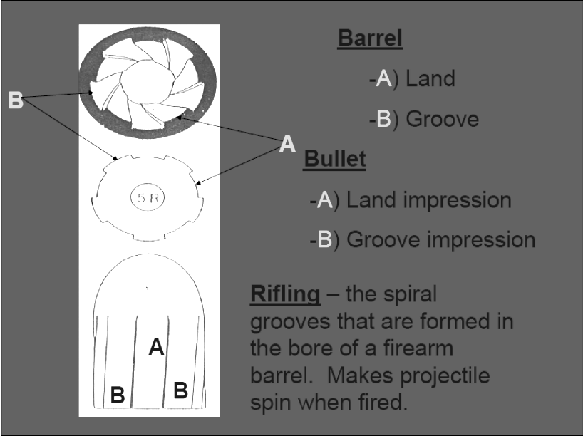
Grooves cut into a gun’s barrel cause it to spiral like a football when it leaves the gun. (not in shotguns) The lands and grooves in a barrel create lands and grooves on the bullet. However, on the bullet, the raised strips are the grooves and the indentations are the lands. Comparing the width/depth, twist/pitch of these grooves may help determine the type of gun that shot it. The uniqueness of other striations may individualize a bullet as evidence.

Procedure:

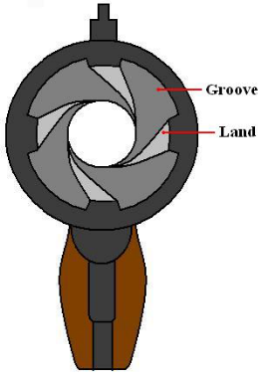
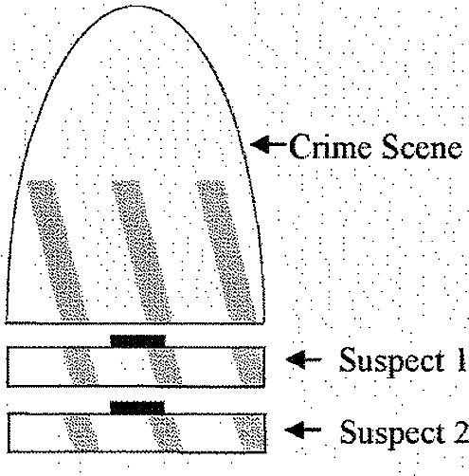
- Pick up the tip of the large grey bullet model marked Crime Scene. In the data table, record the twist imparted by the gun that fired it, the relationship between the widths of the lands and grooves (equal widths, lands wider than grooves, grooves wider than lands), any observations of unique striations or markings and your conclusions.

- Pick up the section of the large grey bullet model marked Suspect 1. In the data table, record the same information for this bullet that you did for the crime scene.

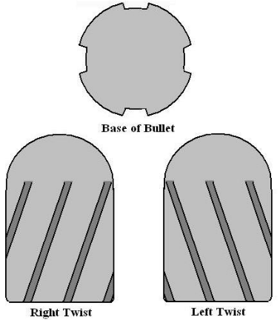
- If the twist and relationship between the lands and grooves match the Crime Scene, then align the protruding magnet of the Suspect 1 section with the bottom of the Crime Scene section. Slowly rotate Suspect 1 to see if you can find an orientation where one set of land and grooves exactly align. Then check to see if the striations or markings that you observe form an uninterrupted path between Suspect 1 and Crime Scene for all pairs of lands and all pairs of grooves. If you find an alignment where all of the lands and grooves are exactly the right corresponding widths and where you see uninterrupted paths of striations lines between Suspect 1 and Crime Scene, you would declare a “match” If not, you should declare “no match” in your data table.

- Remove the Suspect 1 section and replace it with the Suspect 2 section. Repeat steps 2 and 3 for Suspect 2.

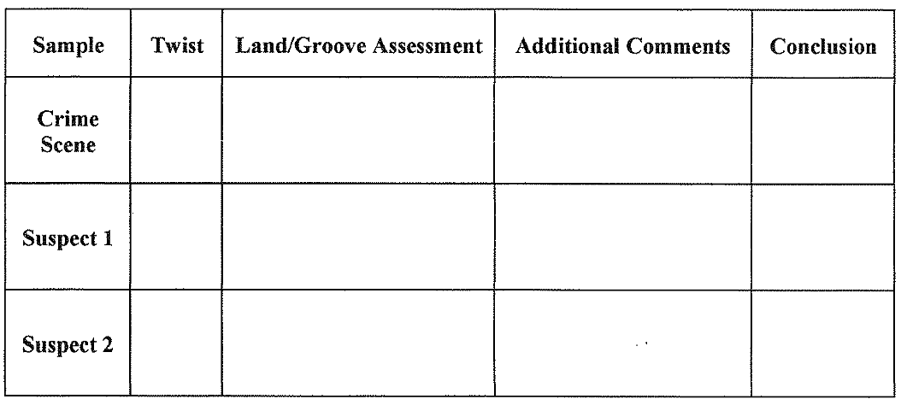
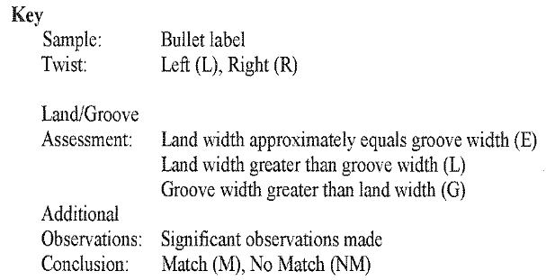

Lab Part 2: Bullet Analysis - Continued - Comparison of Questioned & Known Bullets

Procedure:

- Pick up the embedded bullet marked Crime Scene. In the data table, record the twist imparted by the gun that fired it, and the relationship between the widths of the lands and grooves. (Ex: equal widths, lands wider than grooves, or grooves wider than lands)

- Pick up the bullet marked Suspect 1. Record the same information for this bullet in the data table.

- If the twist and relationship between the lands and grooves match those of the Crime Scene, then place Suspect 1 so that it aligns bottom to bottom with the Crime Scene. Slowly rotate Suspect 1 to see if you can find an orientation where one set of land and grooves exactly aligns between the two bullets. If you find such and alignment, check to see if all of the pairs of lands and grooves also exactly align. Then check to see if the striations or markings that you observe form an uninterrupted path between Suspect 1 and Crime scene for all pairs of lands and all pairs of grooves. If you find an alignment where all lands and grooves are exactly the right corresponding widths and where you see uninterrupted paths of striation lines between the two bullets, you should declare “match.” If you find differences, you should declare “no match.” Record your conclusions in the data table.

- Repeat steps 3 and 4 for Suspect 2 and Suspect 3.

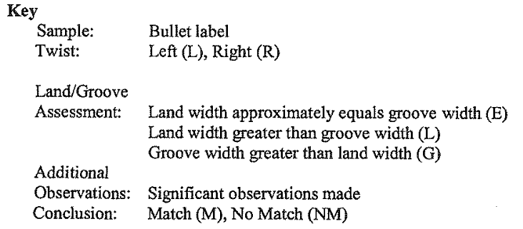

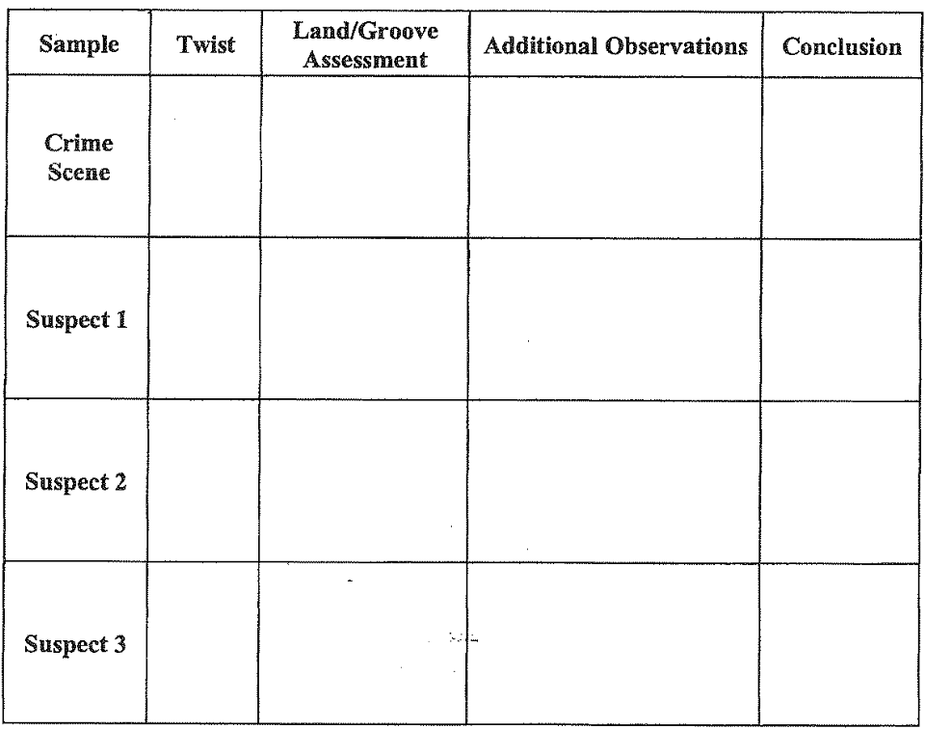

Lab Part 3: Cartridge Case Analysis
Class & Individual – Firing pin impressions, breech face marks, ejector marks, and extractor marks
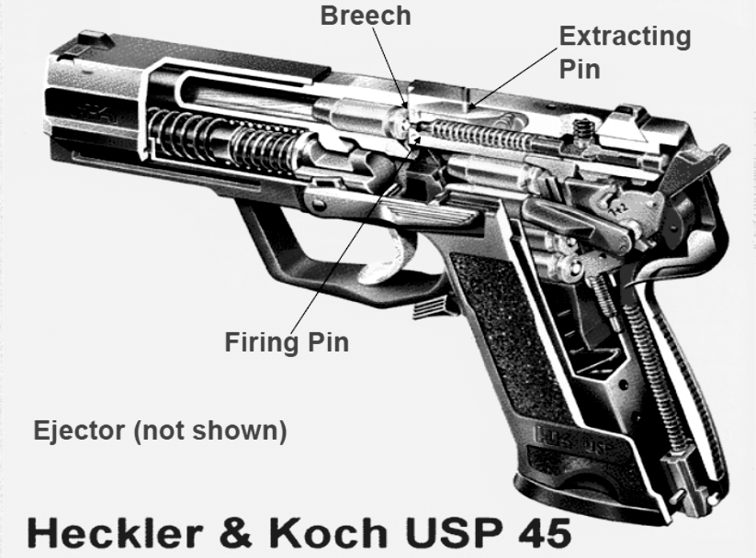
Spent cartridge/shell casings can contain impressions that are crucial to firearms identification. During the discharge of a firearm, the firing pin strikes the primer cap in the center ring of the bottom of the casing, creating a distinct impression somewhat unique to that firearm. When a firearm is shot, the explosive force pushes the bullet forward and the cartridge backward hitting the breechblock as it recoils. The breechblock markings formed on the casing can be unique to a firearm. Other marks can include extractor and ejector marks (striations and impressions) produced as the cartridge is placed in the firing chamber by the extractor and removed from the chamber after firing, by the ejector
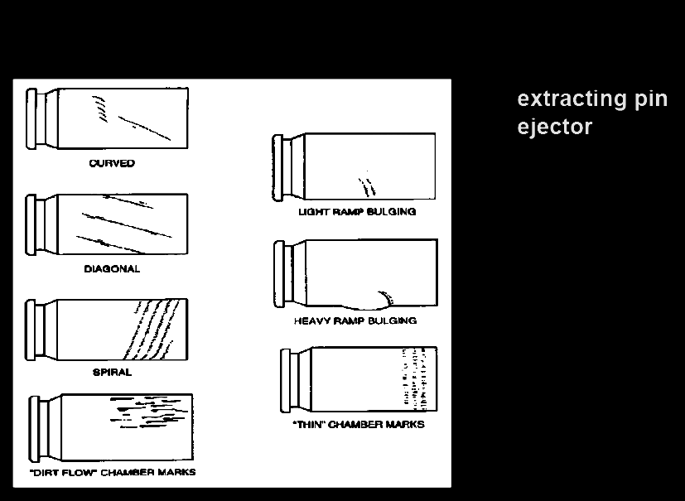
Extractor / Ejector Marks
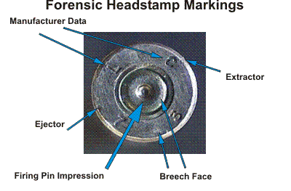
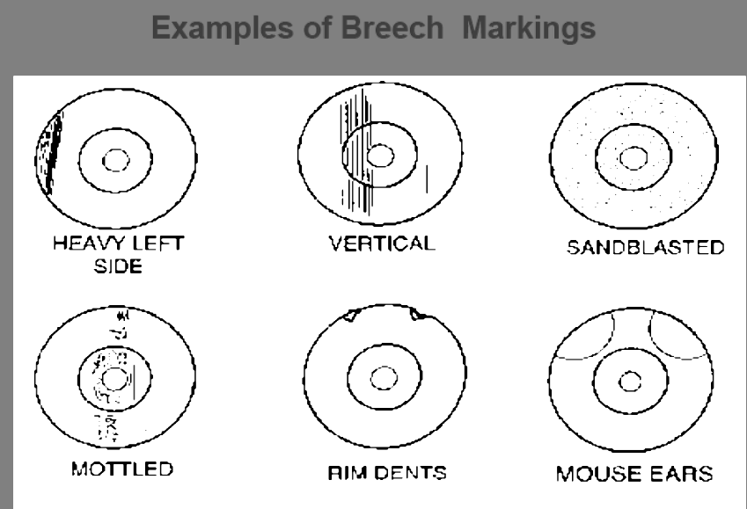

Procedure:

- Pick up the embedded casing marked Crime Scene. In the data table, record the manufacturer’s mark and the caliber.

- Examine the breach face of the casing, including the damage to the primer cap. Refer to the key below and note the location of the dent, the shape of the dent, and the relative depth of the dent. Also, note any other scratches or dents on the breach face cause by recoil.

- Examine the sidewall of the casing. Note any dents or scratches caused by extractors or ejectors.

- Pick up the casing marked Suspect 1. In the data table, repeat steps 2 and 3 for this casing, recording data in table. Compare the markings all of the markings with those on the Crime Scene casing. If all makings are the same size, shape and in the same relative location, then you should declare a “match.” If any markings differ between the two samples, you should declare “no match.”

- Repeat steps 2-4 for Suspect 2 and 3.

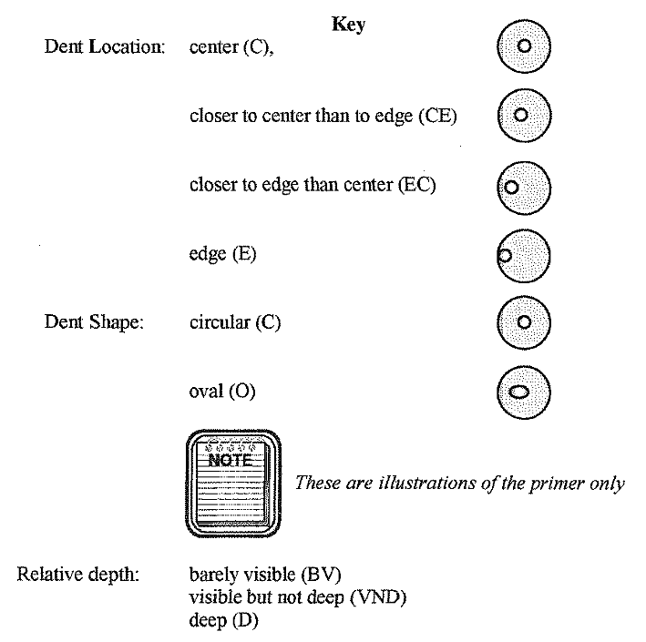
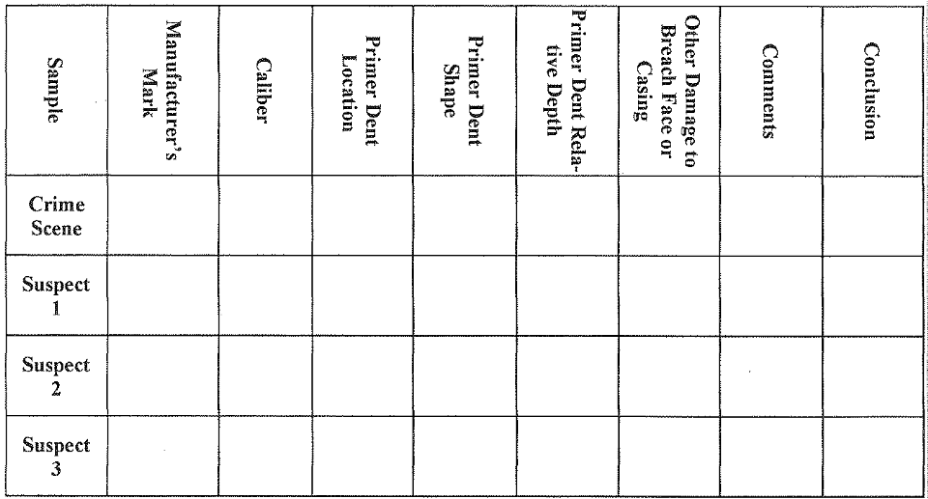
Lab Part 4: Measuring Impact Angle & Trajectory of Bullet
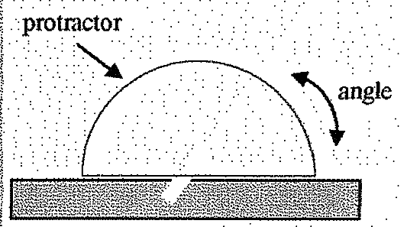

Procedure:

- Sketch the crime scene and the location of any bullet holes you find.

- Place a tip or cone onto the forensic rod and insert the tip/cone into a bullet hole as far as it will go. It should be snug, but do not move the simulated bullet hole blocks.

- Place your protractor/angle finder on top of the rod, to determine impact angle. Record the angle and your reference point. (ex: 30° from wall) You have just determined the flight path for the first bullet.

- Determine the impact angle and flight path for all other bullets.

- Extend the flight paths using laser and string to visualize the complete trajectories of all bullets. Draw these trajectories in your crime scene sketch.

- Do any of the trajectories intersect? If so, what conclusions can you make?



