Lab Activity: Exploring Fingerprinting

Part 1: Examine your own fingerprints.

Using the inkpads and personal identification card, take a set of your own fingerprints.

- Identify the pattern of each your fingerprints.
- Write down the name of pattern under each fingerprint.
- Count the numbers of each pattern. Among all your fingerprints, the numbers of each pattern are as follows:
No. of Arches： __________
No. of Loops： __________
No. of Whorls： __________

Identify the ridgeline details
- Choose the fingerprint with best resolution among all your fingerprints.
- Examine the fingerprint with a magnifying glass.
- Use Table 1 of Part 2 to help identify different fingerprint ridgeline details.

List the names of ridgeline details you can identify.

7. Use the magnetic wand and the dusting powder to lift one of your own fingerprints from a hard surface.

Part 2: Practice the identification skills

Instruction:
- Examine the fingerprint below (Figure 1) with a magnifying glass if necessary.

- To which class does the fingerprint pattern belong?
Write down your answer:

- Use Table 1 to help identify fingerprint ridgeline details. Locate and label at least 8 positions of ridgeline details in Figure 1.

Table 1 Minutiae: Fingerprint ridge details

Bifurcation
Multiple Bifurcation
Trifurcation
Delta
Dot
Bridge
Hook
Double Bifurcation
Short Ridge
Ridge Ending

Figure 1
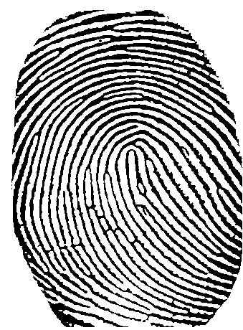

Ridgeline Details:

Bifurcation

Part 3: Try out the steps in analyzing and comparing fingerprints

Case Profile
A suspect was arrested in a burglary case. The police had recovered an excellent latent thumbprint at an unsolved burglary case 3 years ago. There are some indications that these 2 cases may be related.

The recovered print and the suspect’s thumbprints are provided for your analysis. Can a match be made between the direct thumbprints from the suspect and the latent thumbprint found at the crime scene? Imagine you are a fingerprint examiner and you need to evaluate the presented evidence, reach conclusions and provide findings in a report to the law enforcement authorities and the court.

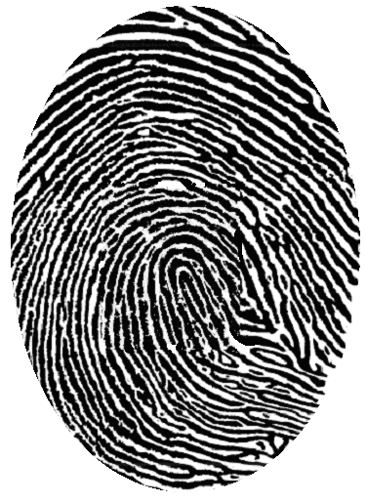  Known left thumbprint from suspect | 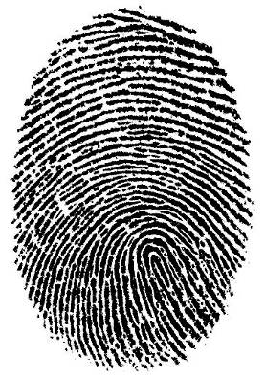  Print recovered from crime scene.
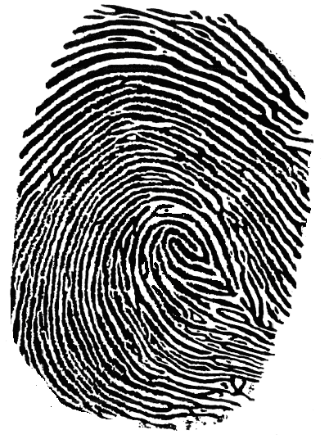  Known right thumbprint from suspect | The five steps in analyzing and comparing fingerprints:  Step 1: Identify the general type of the central area of the fingerprint.  Step 2: Mark fingerprint ridgeline details.  Step 3: Compare the unknown print and the known print, point by point, feature by feature, to see if they match.  Step 4: Evaluate whether the unknown print matches the known print or not.  Step 5: A second examiner verifies the results.

Ridge Details:

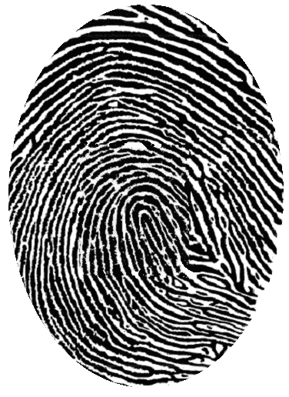

Known left thumbprint from suspect

Pattern Type:

Ridge Details:

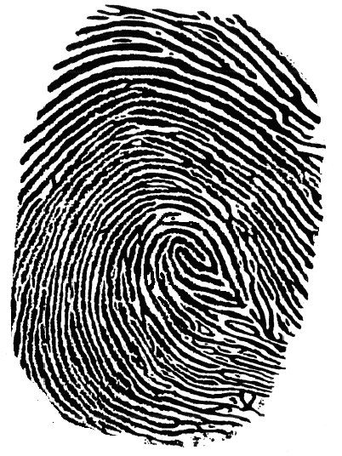

Known right thumbprint from suspect

Pattern Type:

Ridge Details:

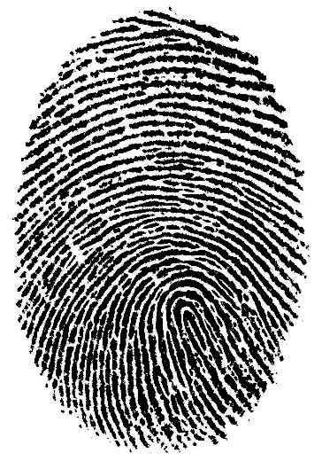

Recovered print from burglary scene

Pattern Type:

Can the suspect be identified? Summarize your findings and report conclusions to law enforcement authorities and the court.

