DNA Forensics Problem Set 2

Problem 7: Rape with Two Suspects
The key portion of the autoradiograph from a single locus probe analysis of various DNA samples in a rape investigation is shown in the figure.  The DNA samples are as follows:  (1) known blood sample of victim  (2) known blood sample from Suspect A  (3) known blood sample from Suspect B  (4) DNA size markers  (5) female fraction from sexual assault evidence  (6) male fraction from sexual assault evidence.  If you are the DNA analyst, you should conclude that: | 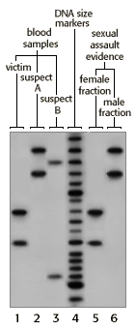

A. | Both Suspects A and B are excluded as the source of the evidence.
B. | Suspect A is excluded as the source of the evidence, but Suspect B cannot be excluded.
C. | Suspect B is excluded as the source of the evidence, but Suspect A cannot be excluded.
D. | Neither Suspect A or B can be excluded as a source of the evidence.
E. | Suspect B cannot be excluded as a source of the evidence. The results with Suspect A are inconclusive.

Problem 8: Another rape with two suspects
The key portion of the autoradiograph from a single locus probe analysis of various DNA samples in a rape investigation is shown in the figure.  The DNA samples are as follows:  (1) known blood sample of victim  (2) known blood sample from Suspect A  (3) known blood sample from Suspect B  (4) DNA size markers  (5) female fraction from vaginal swab of victim  (6) male fraction from vaginal swab of victim.  If you are the DNA analyst, you should conclude that: | 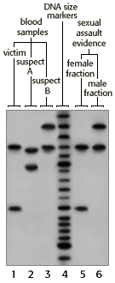

A. | Both Suspects A and B are excluded as the source of the evidence.
B. | Suspect A is excluded as the source of the evidence, but Suspect B cannot be excluded.
C. | Suspect B is excluded as the source of the evidence, but Suspect A cannot be excluded.
D. | Neither Suspect A or B can be excluded as a source of the evidence.
E. | Suspect B cannot be excluded as a source of the evidence. The results with Suspect A are inconclusive.

Problem 9: Reconstructing a missing mother's profile
Forensic scientists from time to time must reconstruct the DNA profile for a missing person from analysis of DNA profiles of close relatives. In this case, a mother of four children is missing. All children have the same biological father. Results from a single locus probe DNA fingerprint analysis for the four children and their father are shown in the figure. Unfortunately, the forensic scientist forgot to label the lane with the father's DNA.  Nevertheless, you are able to deduce that the alleles of the missing mother are: | 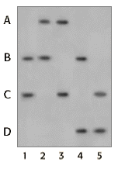
A. B and C
B. A and B
C. A and C
D. B and D
E. A and D

Problem 10: Determining paternity
Results from a single locus probe DNA fingerprint analysis for a man and woman and their four children are shown in the illustration.  Which child, if any, can be excluded as being the biological offspring of the father? | 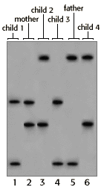
A. Child 1
B. Child 2
C. Child 3
D. Child 4
E. NONE of the children can be excluded

