MCj02788480000[1]**Name ________________________________________ Hr. _____**

DNA Fingerprinting Webquest

**Part 1: DNA Fingerprinting and Forensics**

Go to the website [**http://learn.genetics.utah.edu/**](http://learn.genetics.utah.edu/)

Click on *Virtual Labs: DNA extraction*. This simulation shows how DNA can be removed from cells for analysis.

1. What are three reasons for isolating DNA from human cells?

2. What must be done to the DNA before it can be analyzed?

3. Where in the cell is the DNA located?

4. What steps must be performed before the cheek cell DNA can be analyzed?

a)

b)

c)

d)

5. What are the 2 important ingredients in the lysis solution added to the tube containing the cheek cells? What is the role of each ingredient?

6. Why is salt solution added to the tube?

7. After the tube is placed in the centrifuge, what material sinks to the bottom?

What is left in the liquid?

8. After the liquid is separated into a clean tube, isopropyl alcohol is added. What purpose does this serve?

9. Finally, the tube is placed back in the centrifuge. Where does the DNA end up this time?

10. From you knowledge of DNA, are cheek cells the only source for DNA samples? Name at least four others.

Go back to *Virtual Labs* and click on *Gel Electrophoresis*. This simulation shows one technique by which DNA can be analyzed.

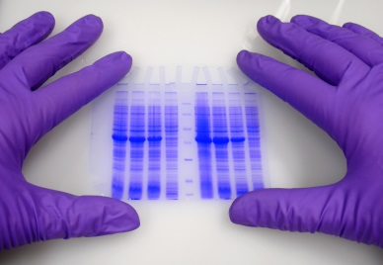

11. Briefly describe how DNA is prepared before “running the gel”.

12. Which DNA segments move the greatest distance?

13. At the bottom of the virtual lab screen, click on the article “Can DNA Demand a Verdict?”

A) About what percent of DNA is unique between individual organisms of the same species?

In human DNA, about how many base pairs is this?

1. List possible substances found at a crime scene that can be sources for DNA evidence:
2. Review the diagram on the right of the webpage that shows forensic DNA analysis (notice that gel electrophoresis is involved). How are these methods used to match DNA from a crime scene to a suspect?
3. Do any two individuals have identical DNA profiles? Explain your answer.
4. Give an example of a circumstance in which the DNA profiles of two individuals could be similar.
5. Can DNA evidence alone convict or clear a suspect of a crime? Explain your answer with examples of how this evidence is used in a court of law.

14. Go to the website <http://www.scq.ubc.ca/a-brief-tour-of-dna-fingerprinting> and read the introduction.

A) Even though the general structure of DNA is the same in all organisms, how is it different in each species, or even each individual?

B) The human genome contains sequences of repeated DNA, with the number and length of these sequences varying between individuals.

What are these sequences called?

What are RFLPs? How are these used to compare different DNA samples?

C) How can DNA be used to identify the parents of a child? Review the case study described in the webpage.

D) How do police forensic labs analyze samples collected from crime scenes?

E) Examine the DNA evidence from the sexual assault case described on the webpage.

What was the purpose of the DNA ladder strands and the control strands?

Which suspect appears to be connected to the crime scene?

F) DNA is a reliable form of evidence, but must be combined with other traditional forms of evidence to convict a suspect of a crime. Describe three problems with DNA fingerprinting:

1)

2)

3)

#1 #2 #3 #4

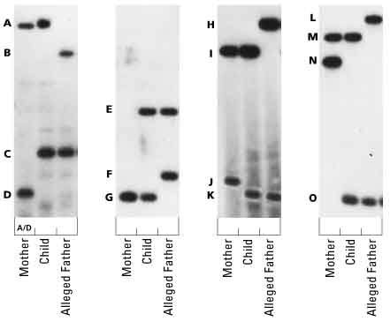 In these four hypothetical paternity cases, DNA "fingerprints" taken from three individuals are shown: a mother, her child, and the child's alleged father. Each profile compares equivalent DNA segments from the three individuals. The two dark bands in each column represent one individual's DNA segments -- one inherited from that individual's biological mother and the other from the biological father. These segments differ in length from person to person; for this reason they are used as genetic markers. Here, each length is designated by a letter, A through O. The two letters associated with each segment indicate the individual's genotype.

**Instructions:**

1. In the table below, write the letters associated with each individual's genotype. For example, the genotype of the mother in the first column is A/D. Then, circle the letter in the child's genotype that represents the gene inherited from the mother.
2. Which "letters" must the child have inherited from its father?
3. Based on this information, what evidence suggests that the alleged father could be biologically related to the child?

***DNA Matching Results***

|  |  |  |  |  |
| --- | --- | --- | --- | --- |
|  | #1 | #2 | #3 | #4 |
| Child |  |  |  |  |
| Mother | A/D |  |  |  |
| Father |  |  |  |  |

**Keep in mind that genetic tests can only absolutely disprove, but not prove, relationship.

**Real World Connection #2: DNA Analysis and Crime Scene Evidence**

|  |
| --- |
| Only a small sample of DNA is needed for DNA fingerprinting - a hair or a semen sample is plenty. A special process called PCR (polymerase chain reaction) is used to copy this DNA millions of times so that the scientists have plenty of copies to work with. It is vital that the sample of DNA is not contaminated with someone else's DNA before doing this (even the dandruff from the technicians' hair would contaminate the sample irreversibly!)  The DNA is cut at particular parts known to be unique to everyone, usually noncoding sections, or “junk” DNA. These parts are very special because they are different lengths. The cut DNA is sorted out into lengths, giving it a barcode-like appearance. Each bar represents a particular length of DNA and the thickness of the bar indicates how much of that length DNA there is. The barcode (DNA fingerprint) is then compared to the suspect's fingerprint and if they match, the DNA must be the same. (Unless they have an identical twin, which means that the DNA could be theirs!)  1. According to Figure 1 below, which suspect has a DNA profile that matches the crime scene specimen?    **Figure 1:** DNA Profiles prepared from crime scene specimens, and from three suspects |
|  |

**Part 2. Use the following website to answer the questions below:** <http://www.dnai.org/d/index.html>

Click on the **Human Identification** button on the bottom.

Click on **profiling** along the top menu.

Click on the last circle with the graph-like spikes.

Use the “play button” to go through the different slides.

1. What do modern DNA profiles analyze?
2. What are STRs and where are they located?
3. How many STRs does the FBI test? ____________
4. How are STR differences detected?
5. What happens when the DNA amplifies?
6. Why does the amplified DNA fluoresce?
7. Why are the DNA fragments run on a gel?
8. How is each fragment detected?
9. How does the laser read the results?
10. In the laser results, what does each peak represent?
11. What do the numbers represent?
12. What is the “random match probability”?
13. Finally, genetic fingerprinting can help us to predict our future health. DNA fingerprinting is often used to track down the genetic basis of inherited diseases. If a particular pattern turns up time and time again in different patients, scientists can narrow down which gene(s), or at least which stretch(es) of DNA, might be involved. Since knowing the genes involved in disease susceptibility gives clues about the underlying physiology of the disorder, genetic fingerprinting aids in developing therapies. Pre-natally, it can also be used to screen parents and fetuses for the presence of inherited abnormalities, such as Huntington’s disease or muscular dystrophy, so appropriate advice can be given and precautions taken as needed.

Do you think knowing your child had a genetic disease prior to its birth would help you or cause you unnecessary stress? Explain your answer.