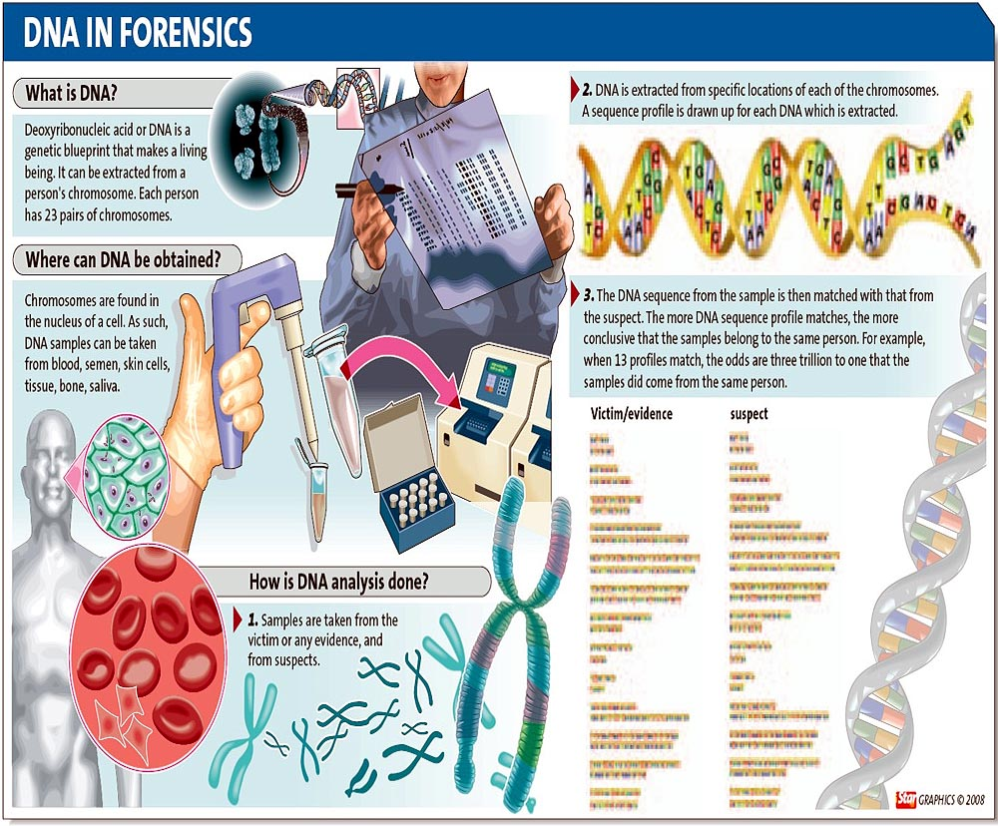

**DNA Typing Review:**

**How is CODIS Regulated?**

* No names or other personal identifiers of the DNA profiles on either index of CODIS are stored. The information that can be searched at the national level:
  + The DNA profile—a set of identification characteristics or numerical representations at each of the various loci analyzed
  + The Agency Identifier of the agency submitting the DNA profile
  + The Specimen Identification Number—a number assigned sequentially at the time of sample collection that does not correspond to the individual’s social security number, criminal history identifier, or correctional facility identifier
  + The DNA laboratory personnel associated with a DNA profile analysis.
* Also, according to the DNA Identification Act of 1994, DNA data is confidential. Access is restricted to criminal justice agencies for law enforcement identification purposes only.
  + Defendants are also permitted access to the samples and analyses performed in connection with their case.
  + If all personally identifiable information is removed, DNA profile information may beaccessed by criminal justice agencies for a population statistics database, for identificationresearch and protocol development purposes, or for quality control purposes.

**What are the Ethical Issues present with a National DNA Database?**

*Should everyone submit DNA to be typed and stored in CODIS?*

* + This could dissuade some from committing crime.
  + Genetic information could be misused or fall into the wrong hands (insurance companies, employers, etc.)
  + Genetic information could be used for profiling (similar to racial profiling).
  + DNA typing is not infallible.
  + If not all citizens have their DNA in CODIS, there could be a negative stigma attached to those that do (indicating they are guilty of a serious criminal act).

*To further investigate and consider this ethical debate visit the following website with various viewpoints and scenarios relating to a national DNA database:*

[**http://www.techniquest.org/DNA/database.php**](http://www.techniquest.org/DNA/database.php)

2

**Figures for this Facts sheet obtained from the following sources:**

[*http://thestar.com.my/news/story.asp?file=/2008/7/19/nation/21869104&sec=nation*](http://thestar.com.my/news/story.asp?file=/2008/7/19/nation/21869104&sec=nation) *– DNA in forensics figure*

[*http://www.biotech.iastate.edu/biotech_info_series/bio6.html*](http://www.biotech.iastate.edu/biotech_info_series/bio6.html) *- DNA and fingerprint figure*

[*http://www.justice.gov/oig/reports/FBI/a0632/intro.htm*](http://www.justice.gov/oig/reports/FBI/a0632/intro.htm) *- National database organization chart*

[*http://www.ncjrs.gov/pdffiles1/nij/sl413apb.pdf*](http://www.ncjrs.gov/pdffiles1/nij/sl413apb.pdf) *- NDIS Accepted PCR Loci Chart*