Honors Chemistry: Chapter 6 Checkpoint Quiz – Study Guide
(1 pt EC for completing)

- Based on the name and chemical formula, predict the smell of ethyl acetate, C₅H₁₀O₂.

- Which of the structural formulas below could exist according to the HONC 1234 rule?
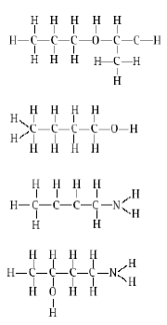

- The atomic number of Phosphorous is 15. How many lone pairs are there in a Lewis dot diagram of PH₃?

- Selenium is in Group 6A of the periodic table. Following the octet rule, how many covalent bonds does Selenium form?

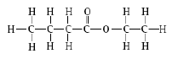
- What is the functional group in the molecule shown to the right?

- What is the name of the compound to the right?

- How can you change the smell of a chemical?

- How many electrons are shared by the two Nitrogen atoms in a Nitrogen molecule? Oxygen?

- What elements are included in the structure of every amine?

- What type of compound is formed when a carboxylic acid reacts with an alcohol?

