Honors Chemistry: Chapter 3 Checkpoint Quiz – Study Guide
(1 pt EC for completing)
- When Rutherford shot alpha particles through a thin sheet of atoms and most passed with a small number bouncing back; what was he able to conclude about the nature of atoms?

- There are three natural isotopes of Lithium (atomic number 3, average atomic mass 6.941); Lithium-4, Lithium-6, and Lithium-7. Which do you predict you would find in the greatest abundance and explain why.

- Look at the following isotope symbols to answer the following questions.
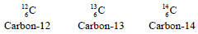
- What does the number on the upper left of the “C” represent?

- What is different about the three different isotopes shown?

- What evidence supports a model of the atom that cannot be divided into smaller pieces?
  - Chemical processes cannot change one element into another
  - Atoms form ions
  - Some alpha particles bounce back when shot toward gold foil.
  - A 1.0 cm3 sample of pure gold will always have a mass of 19.3g.

- Write the isotope symbol for Calcium-44 (atomic number 20).

- What is the result of potassium-40 undergoing beta decay?

- What is the parent isotope of the products of the nuclear reaction shown below?
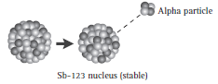
- Scientific evidence indicates that the original source of the elements found on Earth is (are)…?

- The equation below is an example of what kind of reaction?

